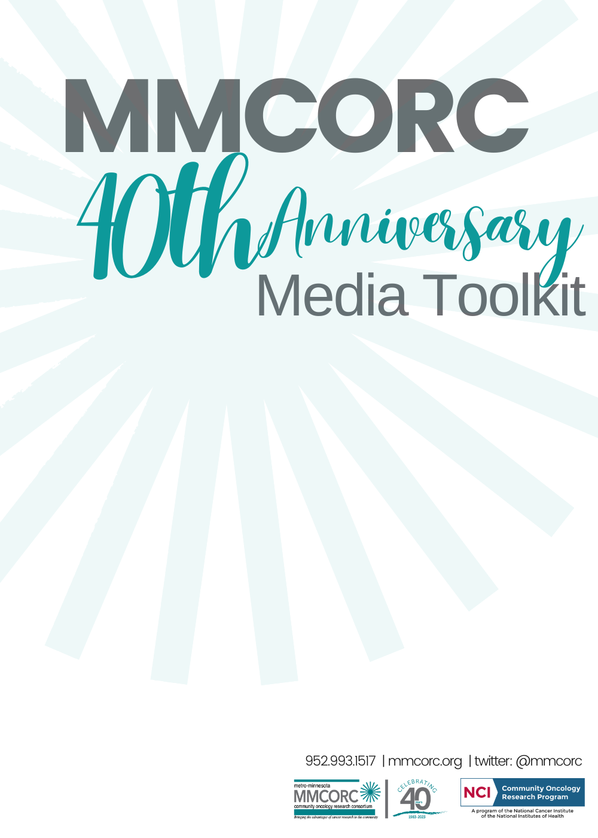

Are you a member hospital or clinic of MMCORC?
Share the following description and logo on your social media or website.

We are celebrating four decades of making a difference together!
Our consortium, the Metro-Minnesota Community Oncology Research Consortium (MMCORC) is a nonprofit research program sponsored by the National Cancer Institute (NCI) and participating hospitals and clinics. MMCORC brings cancer clinical trials to people in their own communities. It also provides access to national clinical trials that patients can participate in while being treated by their local cancer care team.

In 1983, MMCORC received one of the first NCI Community Clinical Oncology Program (CCOP) grant awards, later renamed as the NCI Community Oncology Research Program (NCORP). MMCORC has been awarded NCI grant funding continuously more than 40 years. And we’ve enrolled more than 15,000 patients in cancer clinical trials across all our member sites.

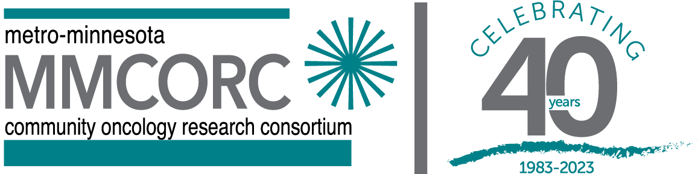

MMCORC Locations
Visit the locations page on our website to discover if MMCORC offers trials in your local hospital or clinic: https://mmcorc.org/locations/

Resources to Explore
Visit the resources page on our website to access helpful links and information: https://mmcorc.org/resources/
How to Get Involved
Ask your doctor about clinical trial options.
Meet the MMCORC research team at your clinic.
Share the content in this packet on your social media.
Follow us on twitter (@mmcorc)
Download the MMCORC App to find clinical trials or check our website.
Media Content for Sharing:
MMCORC has developed social media content that can be copied and pasted into the platform of your choice—great for Twitter and Facebook.

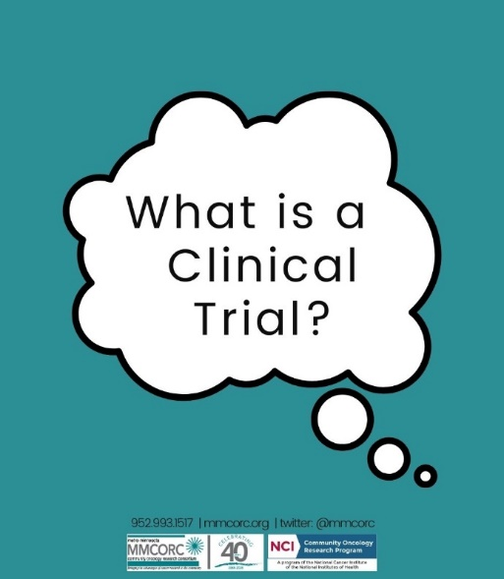

Clinical trials are research studies that involve people. Through clinical trials, doctors find new ways to improve treatments and the quality of life for people with certain diseases. #CancerResearch #MNtrials #NCORP

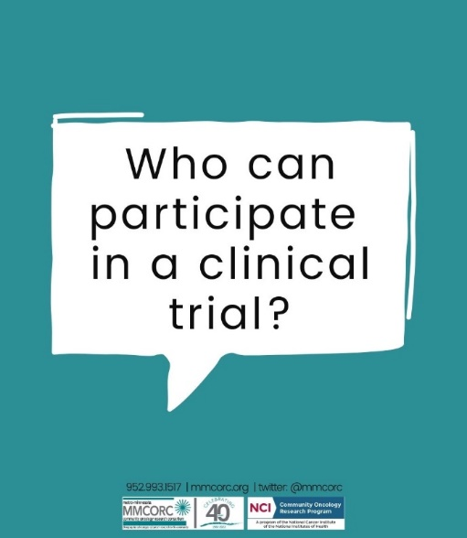

Text Option 1: All clinical trials have guidelines about who can participate. Before joining a clinical trial, a participant must qualify for the study. Criteria are used to identify participants that are the right fit and keep them safe. #CancerResearch #MNtrials #NCORP
Text Option 2: Participation in a clinical trial is voluntary and participants may withdraw from the trial at any time for any reason. Your doctors and research teams work closely to ensure that each participant is a good fit for the study. #CancerResearch #MNtrials #NCORP

Text Option 1: Informed consent is a document and process which every trial participant goes through. It is intended to protect patients. #CancerResearch #MNtrials #NCORP
Text Option 2: During informed consent, researchers provide information to help the participants understand the risks, potential benefits, and alternatives to the study. You can discuss the informed consent and ask questions prior to signing up for the study. #CancerReserach #MNtrials #NCORP

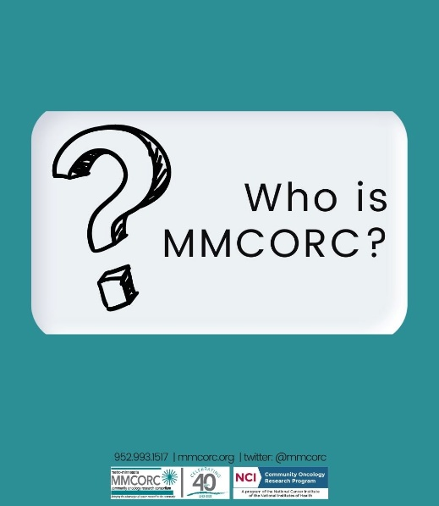

MMCORC is a nonprofit research program sponsored by @theNCI and participating hospitals and clinics. MMCORC provides the opportunity for patients to access national cancer clinical trials in their own community with their local cancer care team. #CancerResearch #NCORP #MNtrials

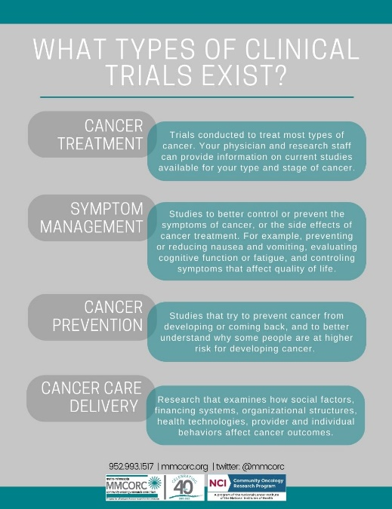

Researchers design cancer clinical trials to test new ways to: treat cancer, screen for cancer, prevent cancer, manage symptoms of cancer and side effects from cancer treatment. #CancerReserach #MNtrials #NCORP

